Project scope is the part of project planning that involves determining and documenting a list of specific project goals, [deliverables](https://web.archive.org/web/20140313032437/http:/whatis.techtarget.com:80/definition/deliverable), tasks, costs and deadlines

* **Scope:** The extent of what a project will produce (product scope) and the work needed to produce it (project scope). *A Guide to the Project Management Body of Knowledge (PMBOK® Guide)*—Fourth edition mentions it is the sum of the products, services, and results produced in a project (Project Management Institute, 2008, p. 440). It is often documented using a scope statement and a Work Breakdown Structure (WBS), which are approved by the project sponsor.
* **Scope creep:** Adding additional features or functions of a new product, requirements, or work that is not authorized (i.e., beyond the agreed-upon scope).

The *PMBOK® Guide* describes scope creep as “adding features and functionality (project scope) without addressing the effects on time, costs, and resources, or without customer approval” (PMI, 2008, p 440).

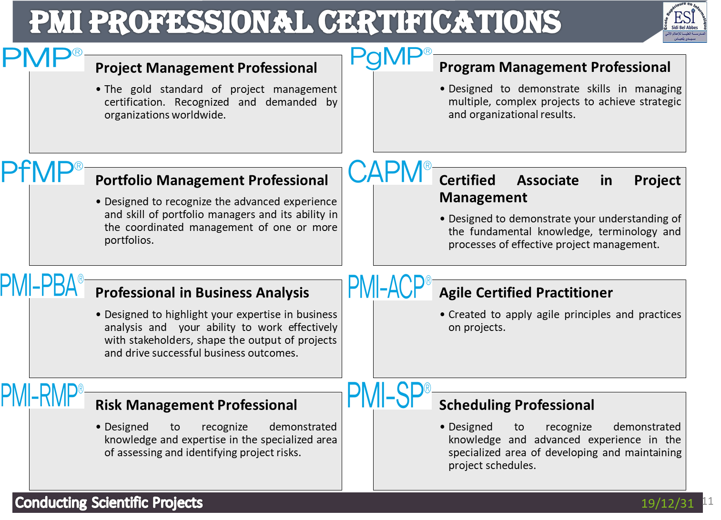

* Project Management : **Project management** is simply the process of **managing projects**
* Project Meaning : we need to understand what a ***project*** is.
* Management Meaning : we need to understand what is implied by the term ***managing***

Project :

* “*The work performed by an* ***organization******one time*** *to produce a* ***unique******outcome****.*” **(Absolute Beginner's Guide to Project Management 2013)**
* “*A* ***unique*** *set of processes consisting of coordinated and controlled activities with* ***start and end dates****, performed to achieve project* ***objectives***. ” **(ISO 21500 Guidance on project management 2012)**

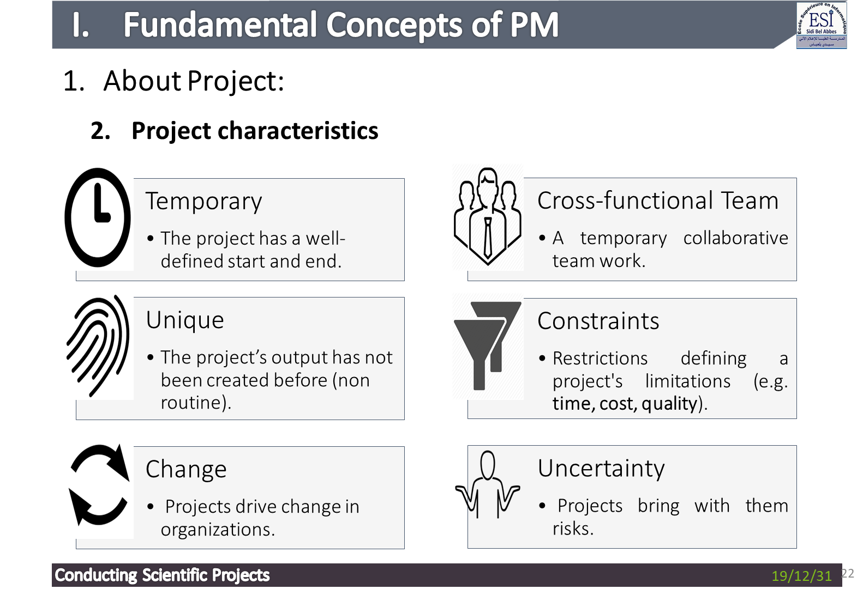

* “A Temporary”. Every project has a finite length, with a distinct start and finish. Projects are not open-ended; they start at a distinct point in time, and they eventually come to a clear and complete conclusion at a later, predefined milestone date.
* “Endeavor Undertaken”/ cross functional team. A project requires some amount of work to be performed by a team; i.e., the project manager and some form of a project team will be required to undertake and perform the work required to develop and deliver the project’s deliverable.
* Unique: The project’s product or service has not been created before. It may be similar to another product but there will always be a certain level of uniqueness.
* Change: A project is aimed at moving an organization from one state to another state in order to achieve a specific objective
* Constraints: The project is defined, planned and executed under certain external (or self-imposed) **constraints** of time, cost, quality, as well as other constraints related to the project’s organisational environment, capabilities, available capacity, etc.
* Uncertainty: The fact that the deliverable of a project is unique and takes time to create brings with it an element of risk. A project risk is an uncertainty that can be a negative or positive factor and it can affect the achievable performance to a significant extent.
  + 1. **Projects vs Operations**
* **Projects** are different from normal day-to-day work (**operations**)
* **Operation** is the **ongoing(مستمرة)**, **repetitive** set of activities that sustain the organization
* In most projects, the operations period begins after the project’s main products have been produced and accepted by the client

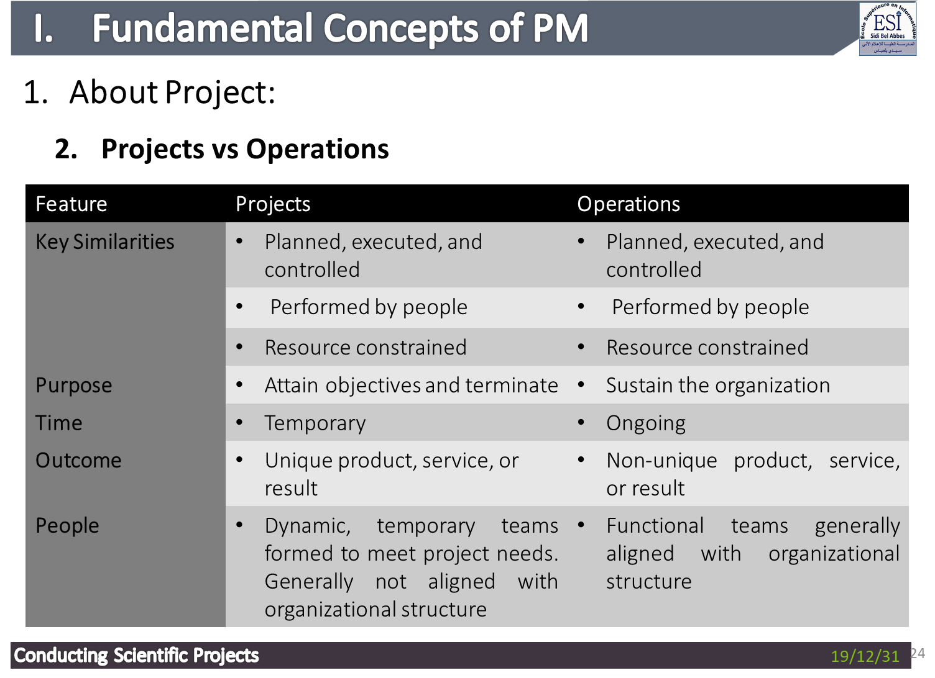

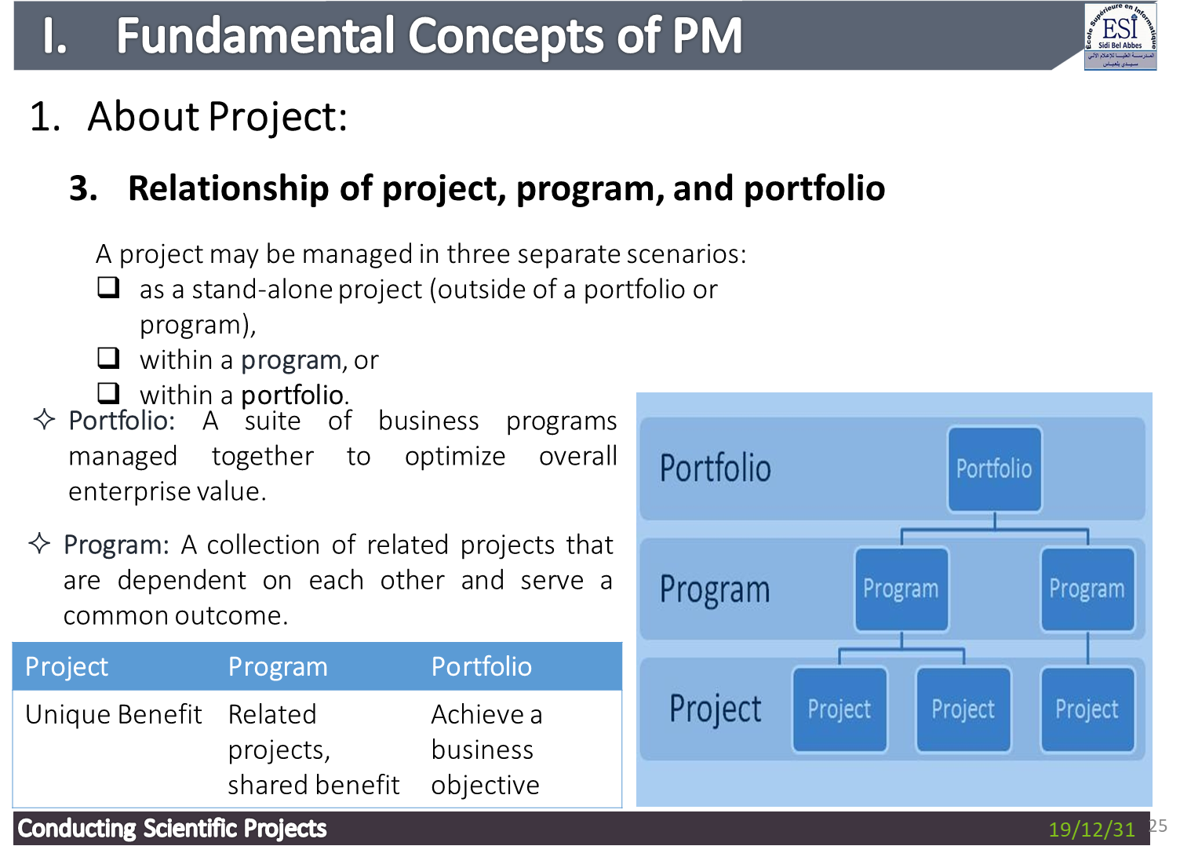

Project Organization Structure

* **Organizational structure** refers to the way a company or organization is setup
* It shows how groups or functions report within the organization.
* It can affect how resources are allocated to the project and it will therefore having an impact on project management

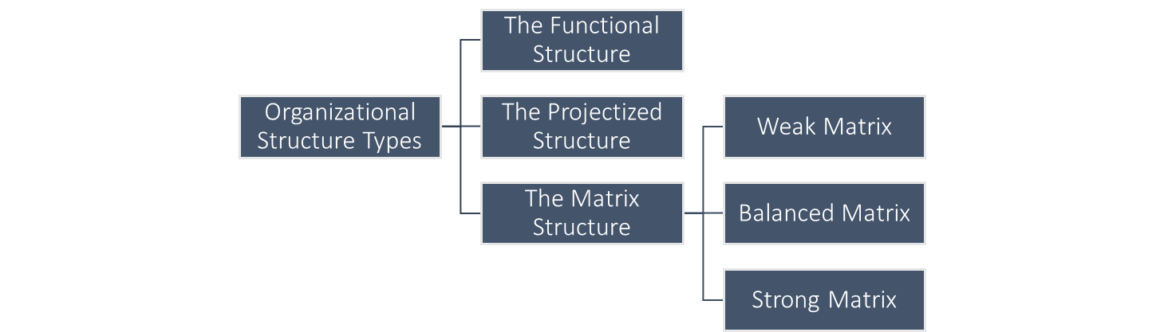

Two of the key project aspects affected by organizational structure types are:

* **Project Manager Authority.**
* **Resource Availability**.

**What is Project Management?**

The application of knowledge, skills, tools, and techniques to project activities to meet the project requirements.” **(PMBOK® Guide 2017)**

The activities of planning, organizing, securing, monitoring and managing the necessary resources and work to deliver specific project goals and objectives in an effective and efficient way.” **(The PM2 Project Management Methodology Guide – Open Edition 2016)**

The PM Lifecycle



* Initiating : Understanding the goals, priorities, deadlines, and risks of the project and obtaining authorization to start the project.
* **Key Activities:**

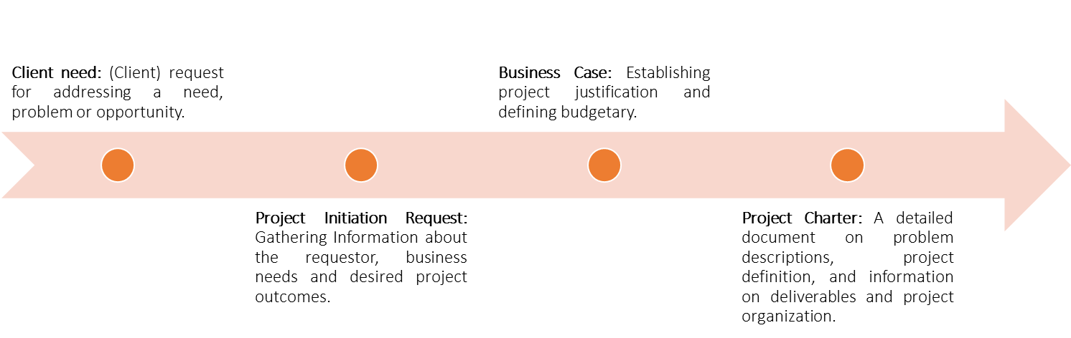

* Planning : Defining and refining objectives of the project and selecting the best course of action to attain those objectives.

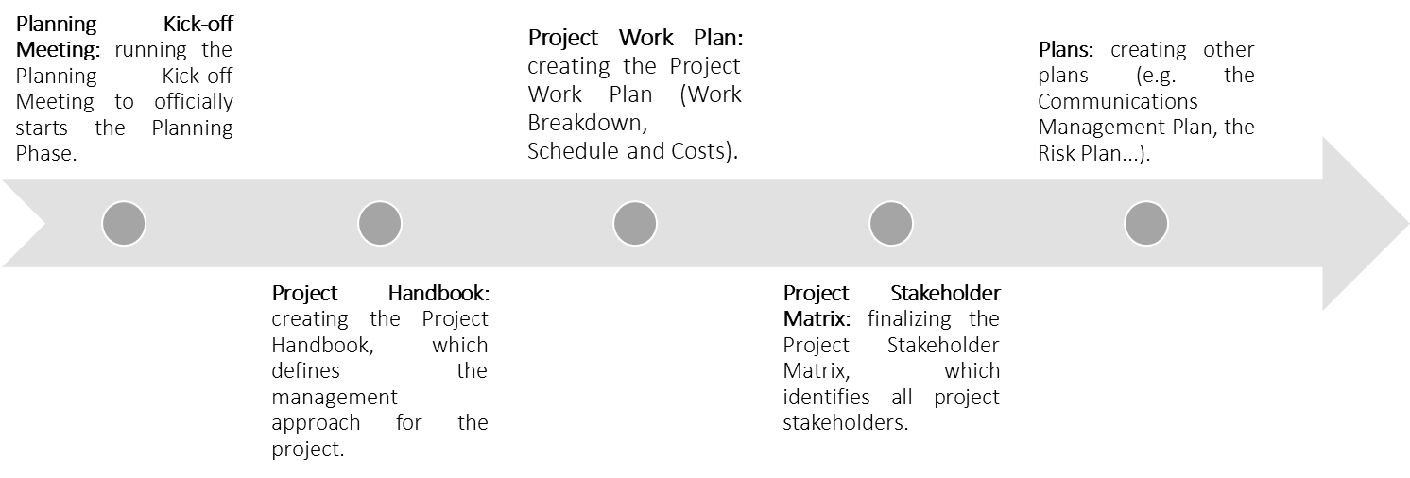

Executing : Coordinating the people and resources to implement the plans.

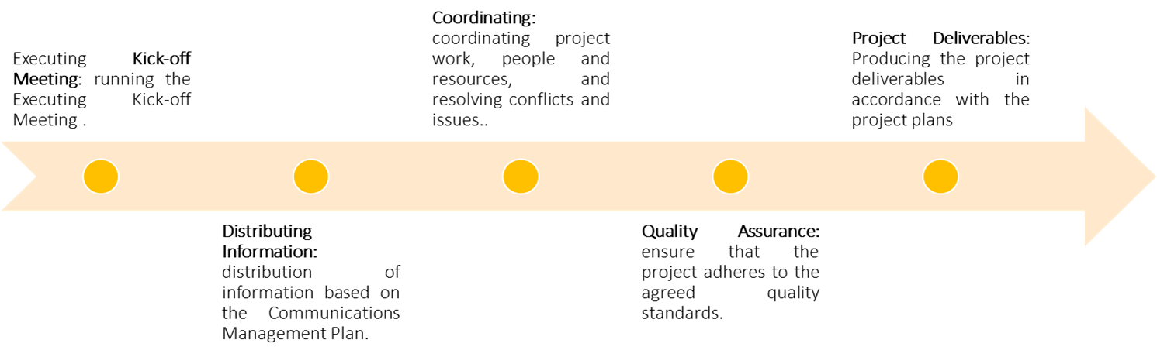

Closure : Formalizing acceptance of project or phase and bringing to an orderly end.

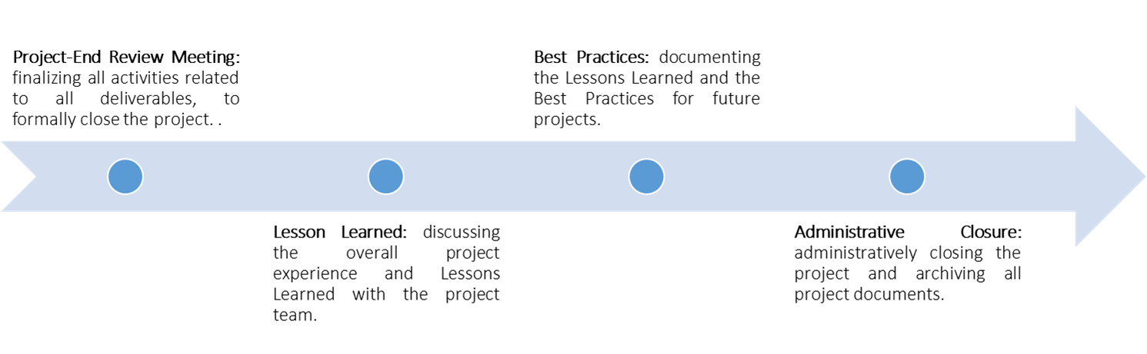

**Monitor & Control**: Track, review, and regulate the progress and performance of the project.

* **Monitoring**
  + Measuring ongoing activities.
  + Monitoring project variables (cost, time, effort, …) against project plans.
* **Controlling**
  + Identifying corrective actions to address deviations from plans, and to properly address issues and risks.

Triple Constraint model : Scope, time/schedule, cost/budget.

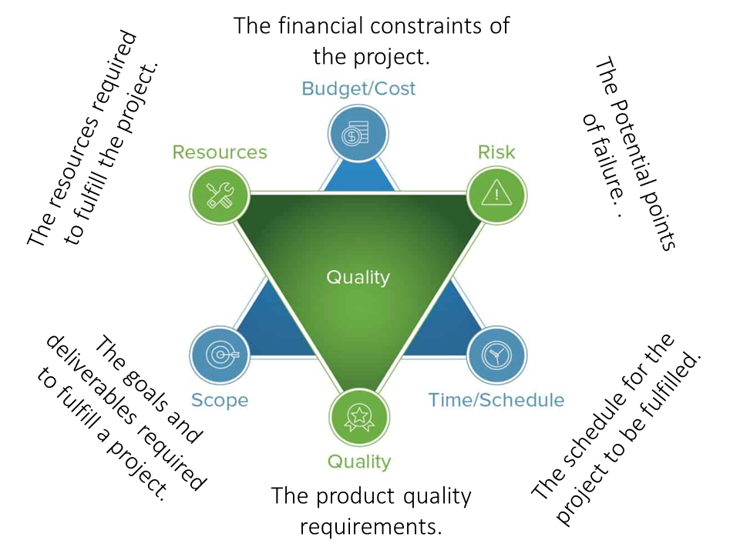

+ Ressources ; Risk; Quality

Pm manager roles :

Competences :

**Technical Project Management**

**Leadership**

**Strategic and business management**

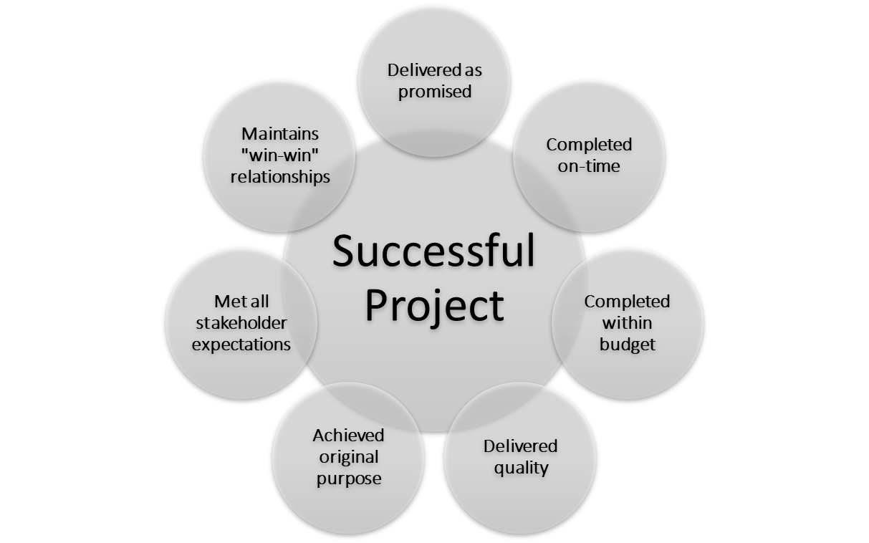

Raisons for troubled project : Organizational-level Issues , Project level issues .

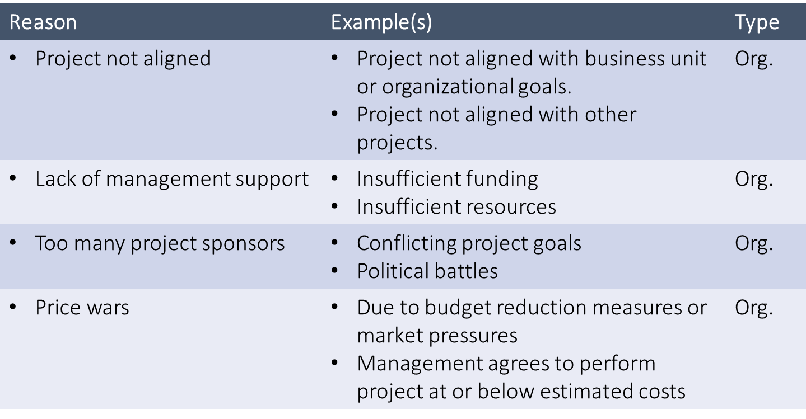

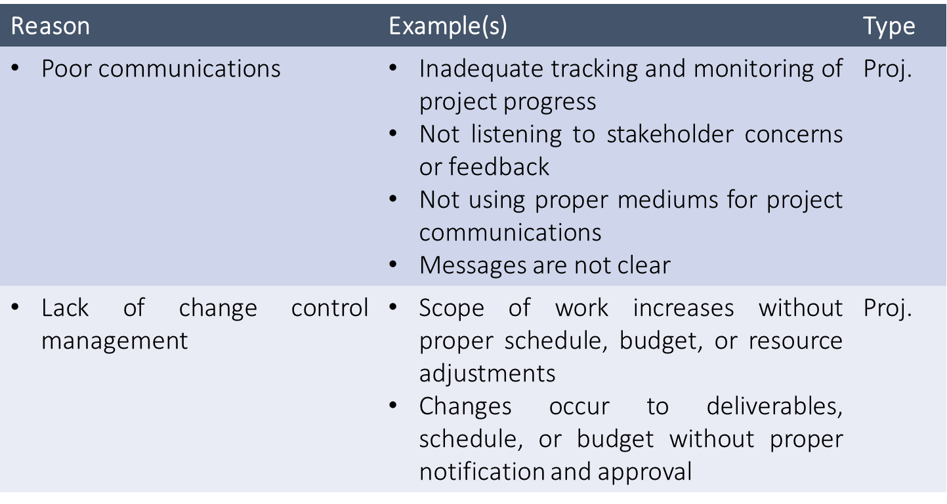

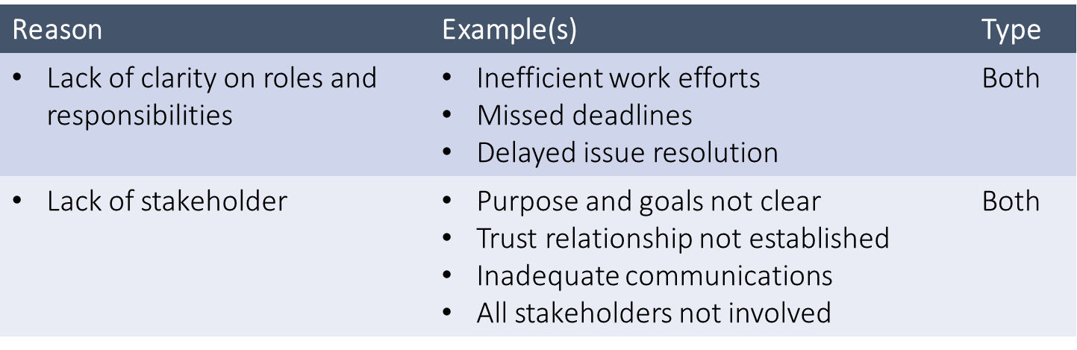

**Essential Project Management Documents:**

* **Project Charter :**
* **Project Work plan :** Plan identifies and organizes the project into the activities, sub-tasks and work packages needed to achieve the project goals
  + **Work Breakdown Structure (WBS)**
  + **Schedule Plan**
* **Other plans** 
  + **Budget plan**
  + **Communication plan**

Cours 2

Research : Attempt to find out information in a systematically and scientific manner.

The systematic collection, analysis and interpretation of data to answer a certain question or solve a problem.

* + **research proposal: A document that contains details about a scientific investigation to be carried out (*i.e.*, not started yet)**
  + It contains details about:
    - The problem to be studied
    - How the investigation will be conducted
    - Expected results and contribution
    - Work schedule / Time frame
    - Budget (for those seeking funds)

Why ?

* + the problem you propose to investigate is significant enough to warrant the investigation,
  + the method you plan to use is suitable and feasible, and
  + the results are likely to prove fruitful and will make an original [or significant] contribution.
  + In short, what you are answering is 'will it work?‘

**Research plan :**

